LAB Logbook

Lab 1
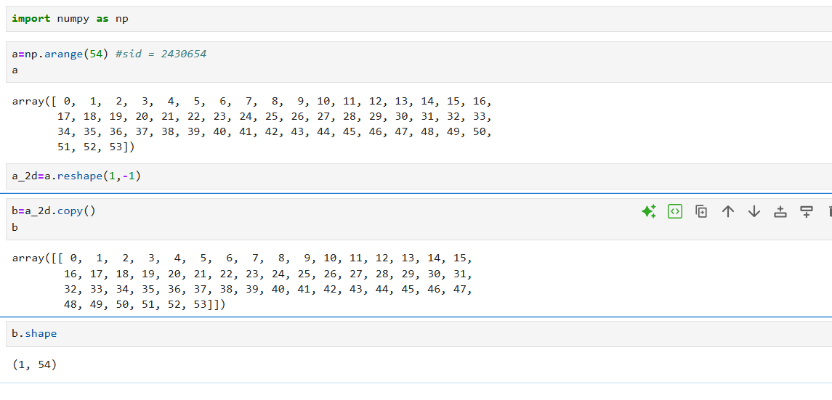
Lab 2
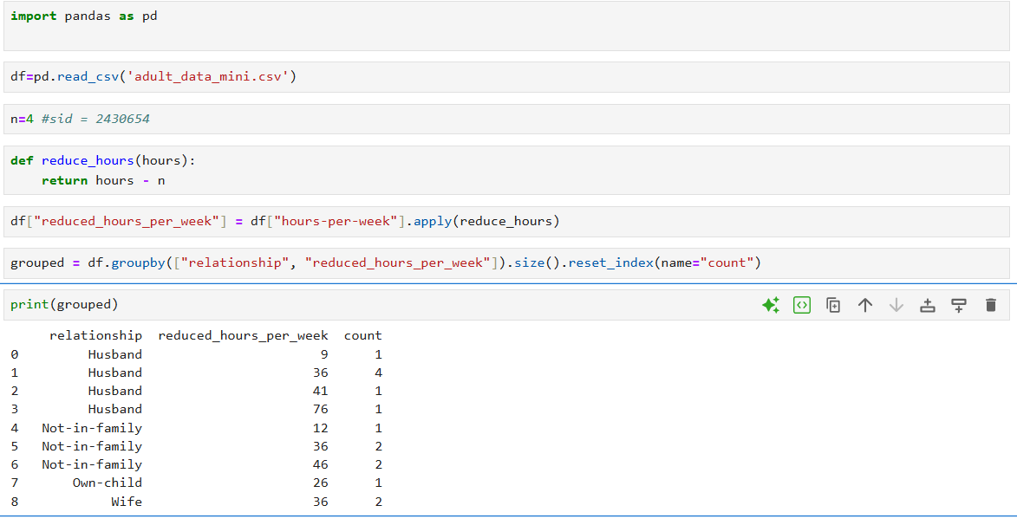

Lab 3
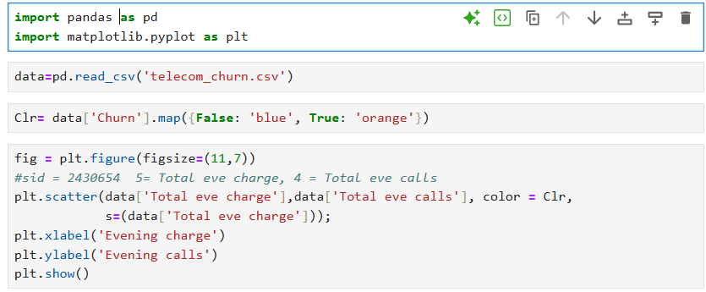
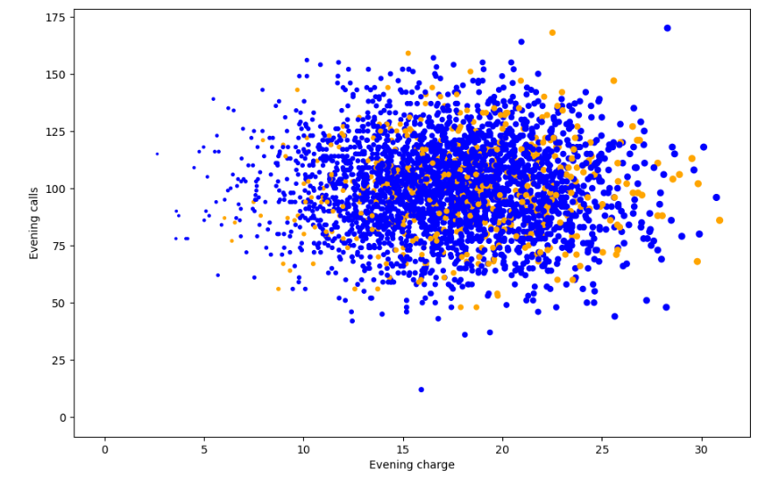
Lab 4
Code
# --- Import libraries ---
import pandas as pd
import numpy as np
import tensorflow as tf
from tensorflow import keras
from sklearn.metrics import mean_absolute_error
from sklearn.preprocessing import MinMaxScaler

data = pd.read_csv(r"C:\Users\Teja9\Downloads\data_stocks.csv")

data_a = np.array(data)

n = data_a.shape[0]
train_end = int(0.8 * n)
data_train = data_a[:train_end, :]
data_test = data_a[train_end:, :]

X_train = data_train[:, 1:]
y_train = data_train[:, 0]
X_test = data_test[:, 1:]
y_test = data_test[:, 0]

scaler_X = MinMaxScaler()
X_train = scaler_X.fit_transform(X_train)
X_test = scaler_X.transform(X_test)

y_min = y_train.min()
y_max = y_train.max()
y_train_norm = (y_train - y_min) / (y_max - y_min)
y_test_norm = (y_test - y_min) / (y_max - y_min)

first_layer_neurons = 654
second_layer_neurons = 327

model = keras.Sequential([
keras.Input(shape=(X_train.shape[1],)),
keras.layers.Dense(first_layer_neurons, activation='relu', kernel_initializer='normal'),
keras.layers.Dense(second_layer_neurons, activation='relu', kernel_initializer='normal'),
keras.layers.Dense(1) # Output layer
])

model.compile(optimizer='adam', loss='mean_squared_error', metrics=['mae'])

print(model.summary())

history = model.fit(
X_train, y_train_norm,
validation_split=0.1,
epochs=10,
batch_size=32,
verbose=1
)

pred_norm = model.predict(X_test)

pred = pred_norm * (y_max - y_min) + y_min

mae = mean_absolute_error(y_test, pred)
print("Mean Absolute Error (MAE) on test set:", mae)

Output
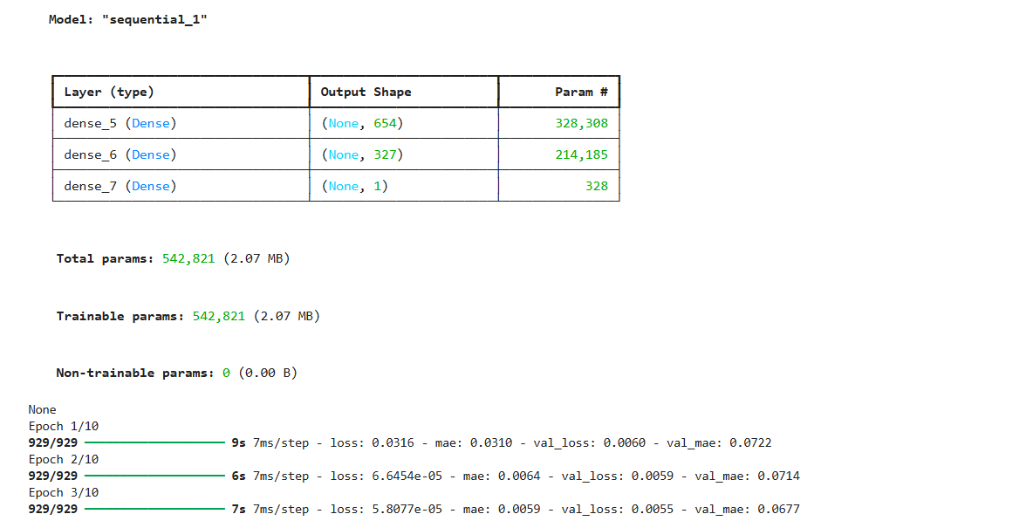
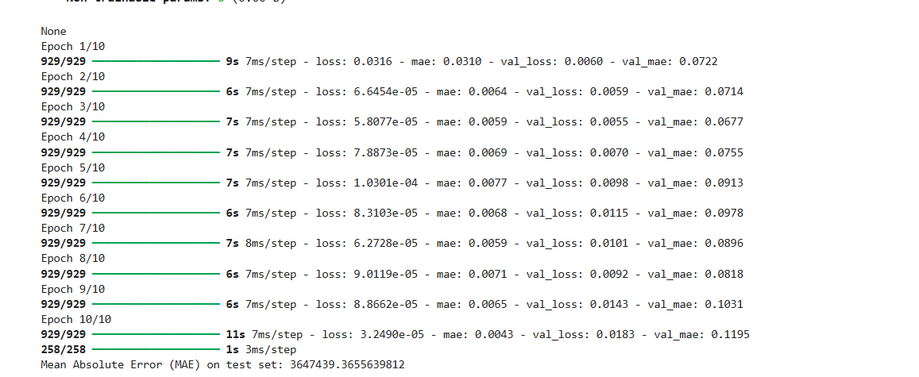
Lab 5
Code
import tensorflow as tf
from tensorflow import keras
from sklearn.model_selection import train_test_split
import numpy as np

# Example data (replace with your actual dataset)
X = np.random.rand(1000, 50, 5)
y = np.random.rand(1000, 2)

X_train, X_test, y_train, y_test = train_test_split(X, y, test_size=0.2, random_state=42)

# Modified CNN model
model = keras.Sequential([
keras.layers.Conv1D(50, 5, padding='same', input_shape=(50, 5), activation=tf.nn.relu, kernel_initializer="normal"),
keras.layers.MaxPooling1D(7),
keras.layers.Conv1D(100, 5, padding='same', activation=tf.nn.relu, kernel_initializer="normal"),
keras.layers.GlobalMaxPooling1D(),
keras.layers.Dense(25, activation=tf.nn.relu, kernel_initializer="normal"),
keras.layers.Dense(2)
])

model.summary()

model.compile(optimizer='adam', loss='mse', metrics=['mae'])

history = model.fit(
X_train, y_train,
epochs=9, # 5 + 4 = 9
batch_size=50,
validation_split=0.2,
verbose=1
)
mse, mae = model.evaluate(X_test, y_test, verbose=1)
print(f"Test Mean Absolute Error (MAE): {mae:.5f}")

OUTPUT
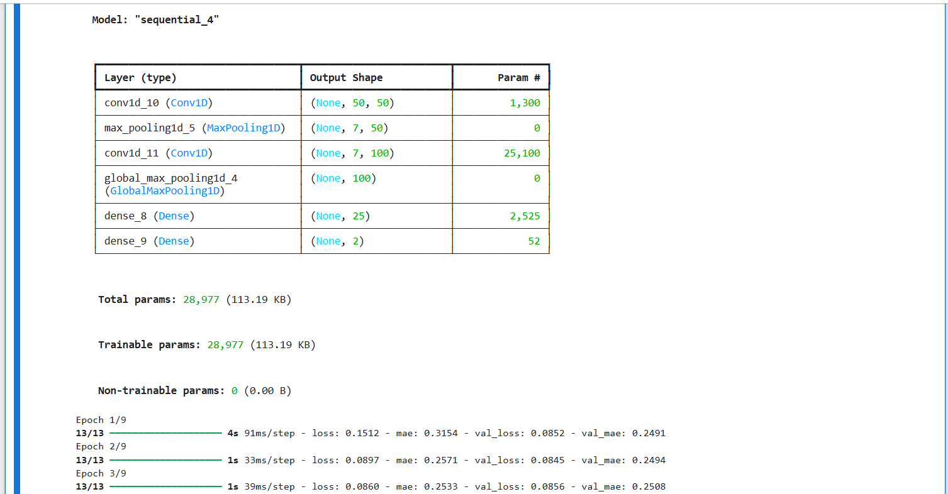
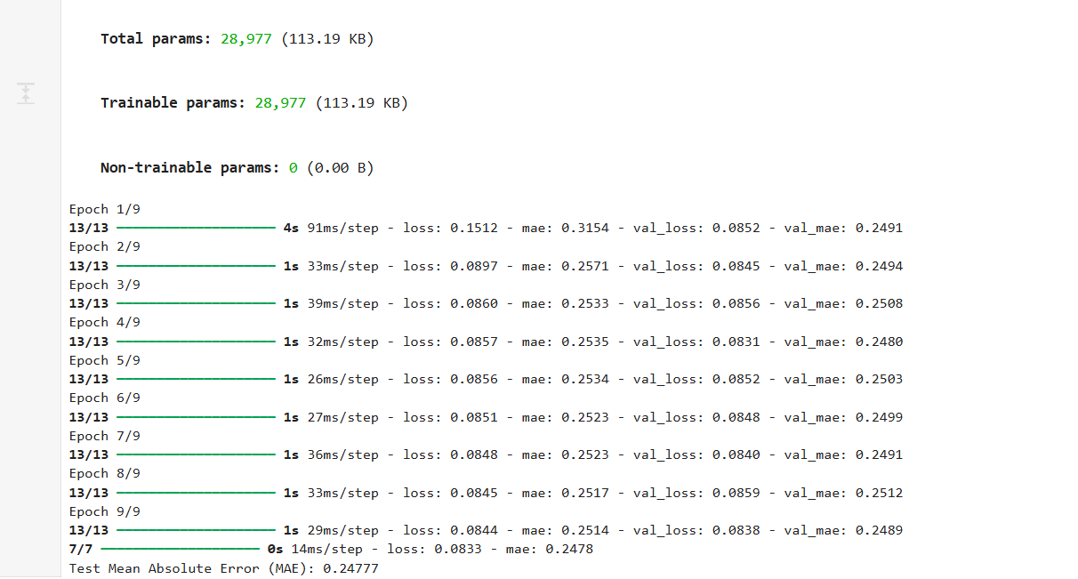

Lab 6
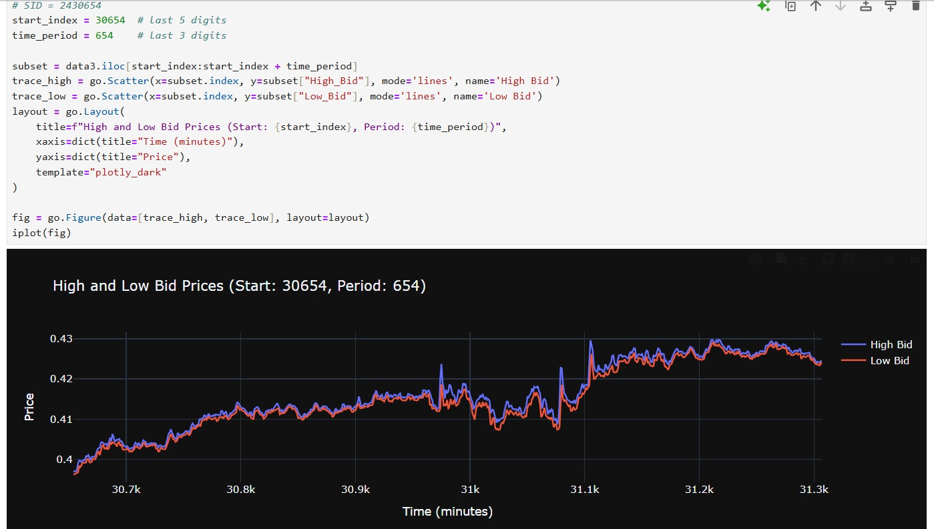

Lab 7
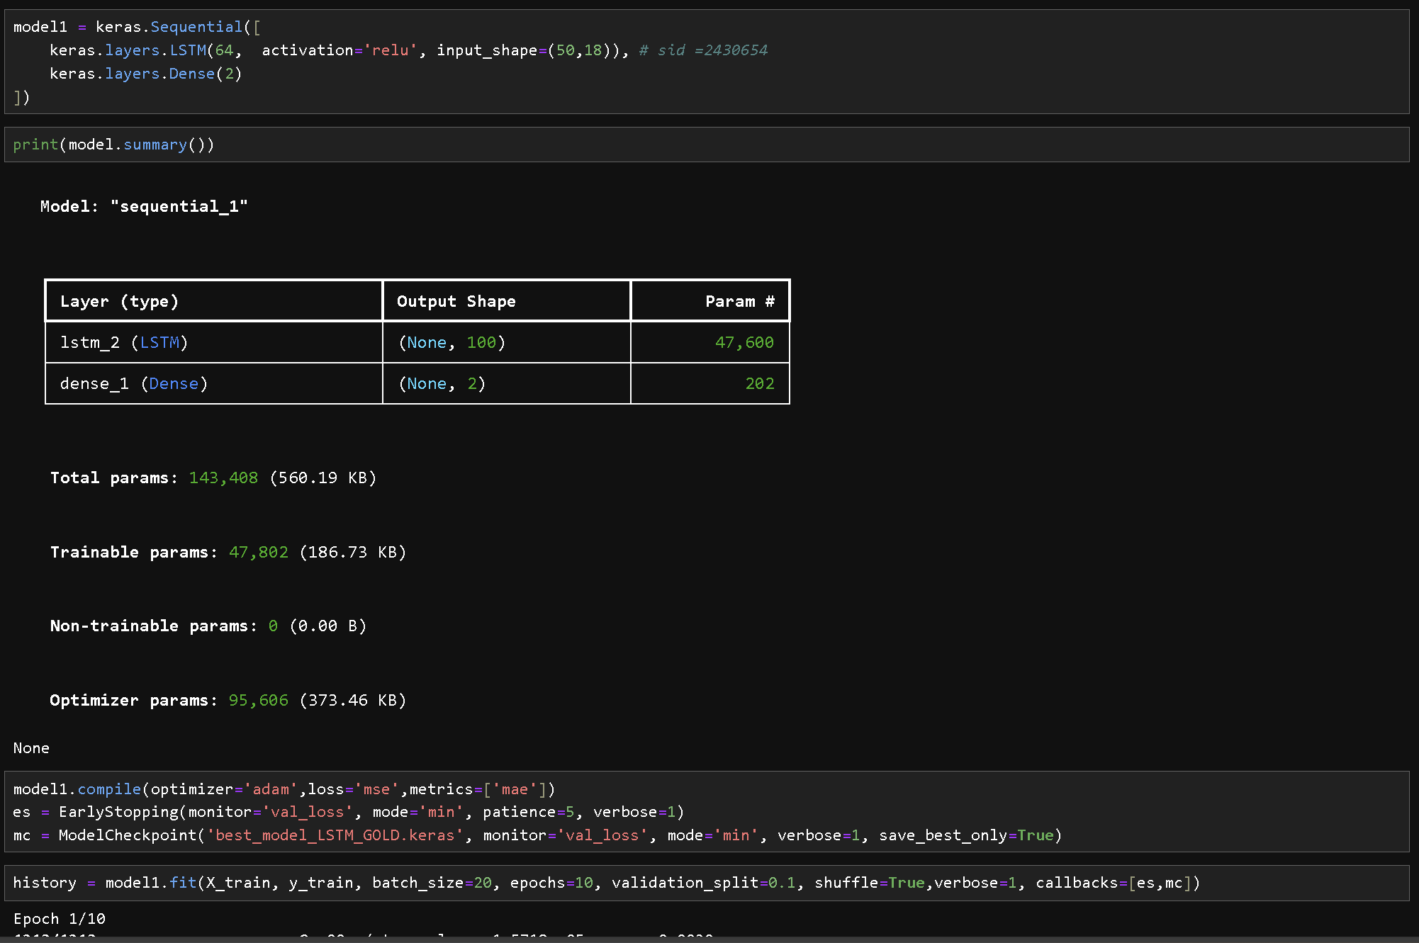
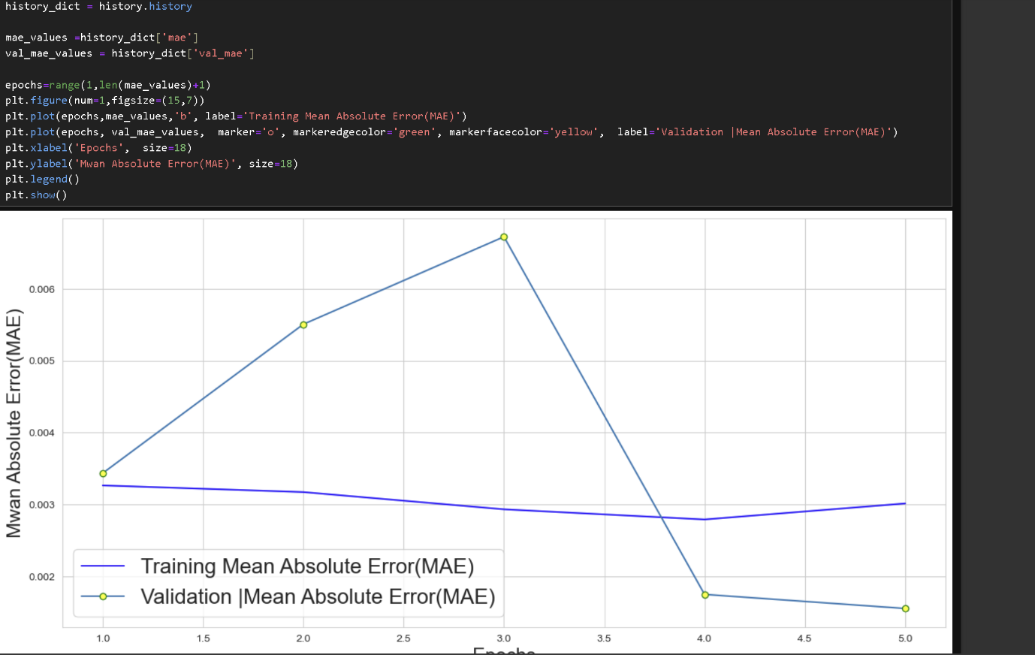

Lab 8

Lab 9

Lab 10

Lab 11

Lab 12

